WeRateDogs Twitter Data Analysis

This consistent growth trajectory suggests that the content posted by WeRateDogs resonates well with the audience, leading to a gradual and sustained increase in the number of likes. It is also indicative of a well-curated content strategy that keeps the followers engaged. Moreover, the analytics show that while the likes have seen a significant increase, the retweets have maintained a steadier pace. This could reflect the nature of user interactions on Twitter, where users are more likely to 'like' to show appreciation quickly, whereas retweeting would mean a higher level of endorsement, which users may not do as frequently. The graph also underscores the importance of tracking such metrics over time to identify patterns and adjust content strategies accordingly.

# Development of Likes and Retweets Over Time

The visual analysis of WeRateDogs Twitter data over time reveals intriguing patterns in user engagement. Key insights include a steady growth in likes, indicating increasing popularity or engagement. Retweets are less volatile, suggesting a more cautious approach to sharing content. The lack of sharp spikes suggests organic growth, while the faster growth of likes compared to retweets could reflect a preference for this form of engagement. These trends are important for understanding the account's reach and can inform future content strategies.

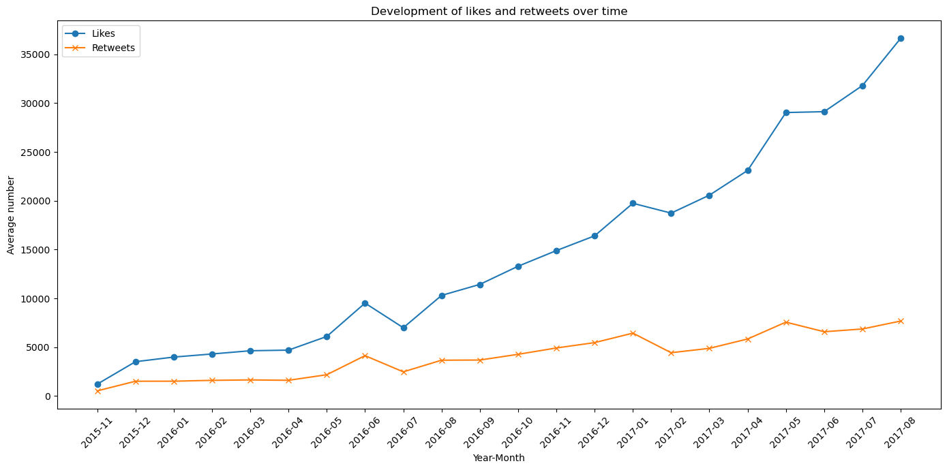

The predominance of higher ratings aligns with the lighthearted and positive nature of WeRateDogs, a platform known for its humorous take on dog ratings. The infrequency of lower ratings can be interpreted as an inherent feature of the platform's brand, which is to celebrate dogs rather than to critique them. The distribution showcases the unique rating system of WeRateDogs, which often features ratings that exceed traditional scales, reflecting the humorous and exaggerated adoration of dogs that the account is known for. Such an optimistic skew in the ratings is not just a reflection of the quality of dogs featured but also speaks to the upbeat community that the account has fostered.

# Distribution of the Ratings

The distribution of ratings given by WeRateDogs shows a clear right skew, with a preference for higher ratings. High ratings between 10 to 14 are common, peaking at 12, suggesting a tendency towards positive feedback. Low ratings are uncommon, potentially reflecting a positive bias or high-quality content. The distribution's deviation from normality is typical in social media where users may round up ratings due to positive sentiment or to foster social interaction.

